Project Description

**IOT05B6**

Major Project

***Internship 2020 (Verzeo)***

# Problem Statement: - (as given on the mail)

**IoT controlled smart home**  
Setup a Google assistant applet from IFTTT to trigger a web request which will  
update a field in Thing Speak cloud. Then read the data from Thing Speak cloud using Arduino to  
control the appliances in your home from anywhere in the world.  
Ex:- From your mobile phone, if you say- “ok google” Turn on the light” from anywhere, it should  
turn on the light in your home.

Required Components: -  
1) Arduino Uno with cable  
2) Esp8266(Wi-Fi module)  
3) 5v Relay two channels  
4) 230v bulb along with holder  
5) Wires  
6) Jumper cables

**Project Description: -** The project objective is to make IFTTT applet that sends Data to ThinkSpeak channel (using API keys) from Arduino. (using AT commands in the Arduino IDE Serial console). It then reads the data from the ThinkSpeak cloud, in order to control sensor like: - **Temperature Sensor (DHT) or Light (Bulb)**.

Channel and Applets: -

1. **IFTTT channel/applet: -**

**Link :-** [**https://ifttt.com/my_applets**](https://ifttt.com/my_applets)

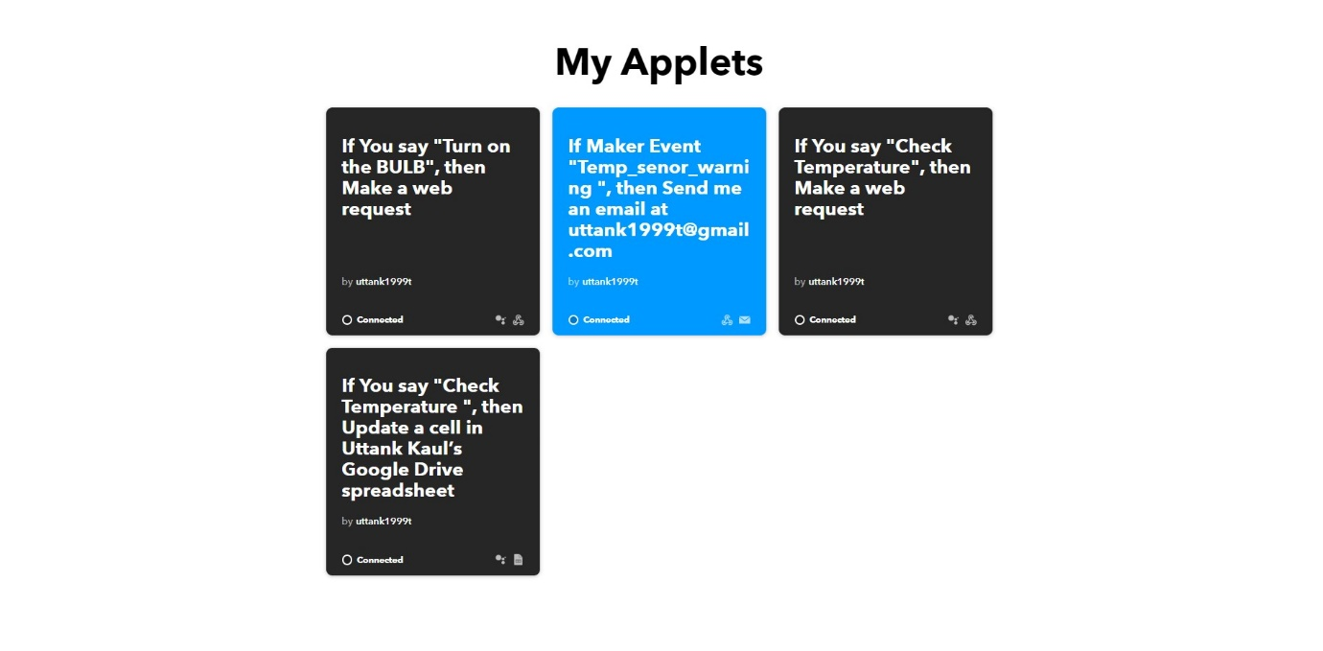

1. **Light Controller: -**  This applet makes web request to ThinkSpeak cloud in order change the value of BULB to 1(**HIGH**) or 0(**LOW**), which will result enable **us to control the lights**

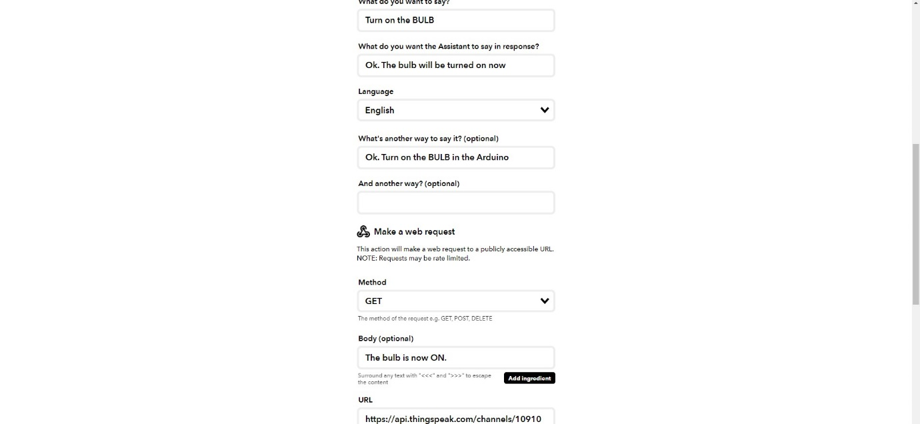

1. **DHT Senor: -**

This Following IFTTT applet updates the value of given by DHT sensor (using Arduino), to the ThinkSpeak Channel.

It then updates the same value to **Google Spreadsheets. (log).**



Thus, if you say **“Check Temperature**” to the Google Assistant, the value will update from DHT Controller.

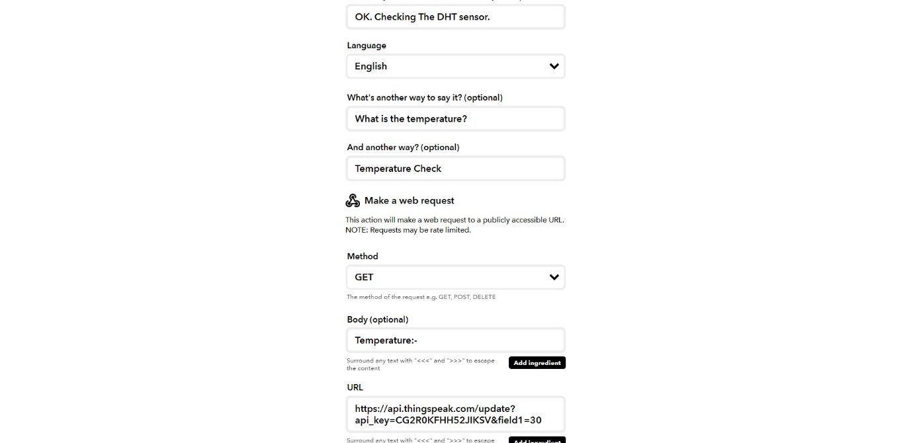

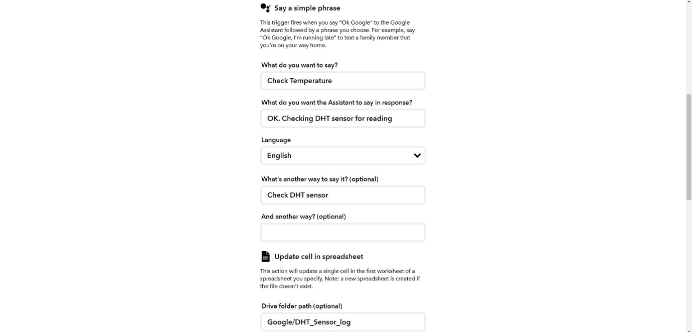

1. **Webhooks Email service: -**

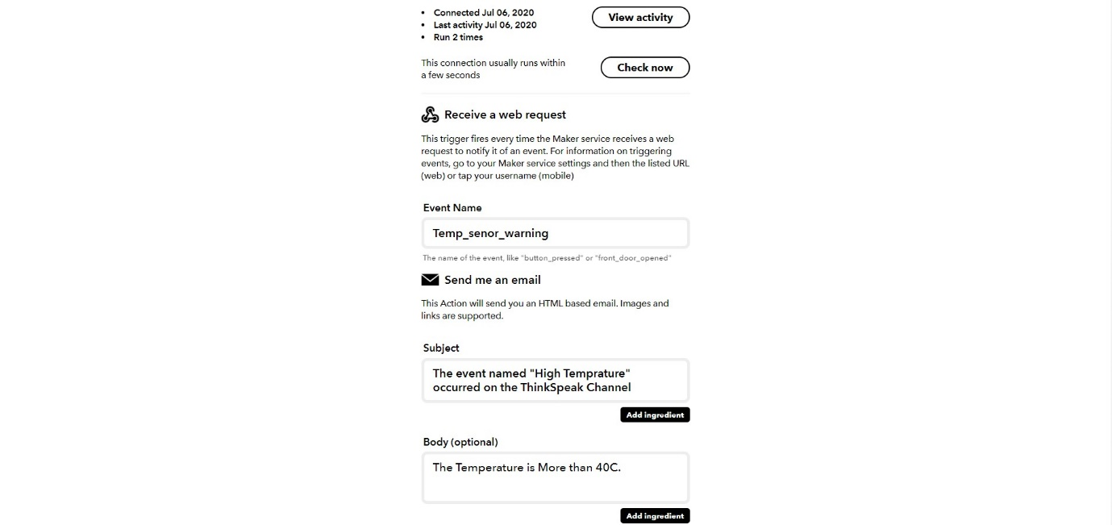

**Note: -** If the Temprature **greater than 40**. It will trigger an alarm in form of email, that will send to your Email address. (that was linked with IFTTT account).

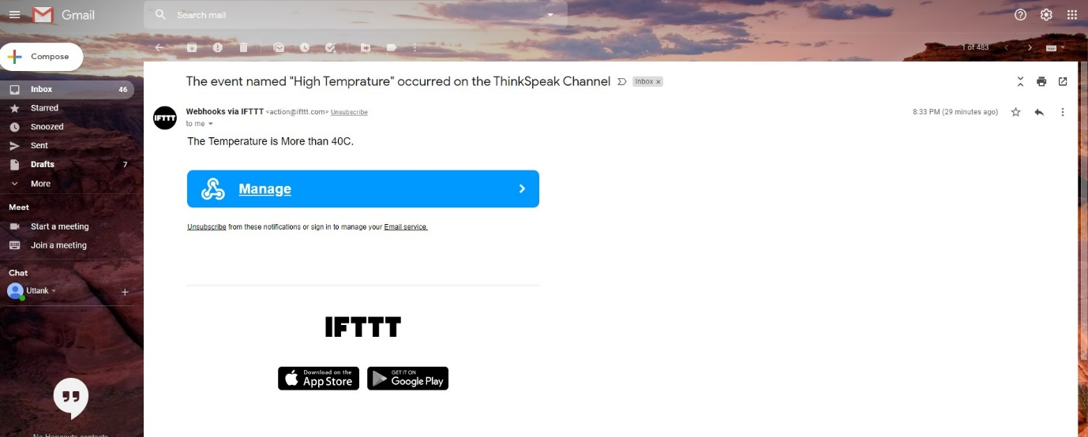

You will receive a mail, similar to the above.

**Note: -** The Temprature reading is acquired from DHT senor using **ThinkSpeak channel.**

1. **ThinkSpeak Channel: -** This channel is made in order to update the value given from the IFTTT applet (say. DHT sensor).

Arduino device then reads data from the ThinkSpeak Channel below

Channel id: - 1091001.

Link: - <https://thingspeak.com/channels/1091001>

**Note: -** API keys can be found in **Channel API keys.txt** file in ThinkSpeak Channel folder.

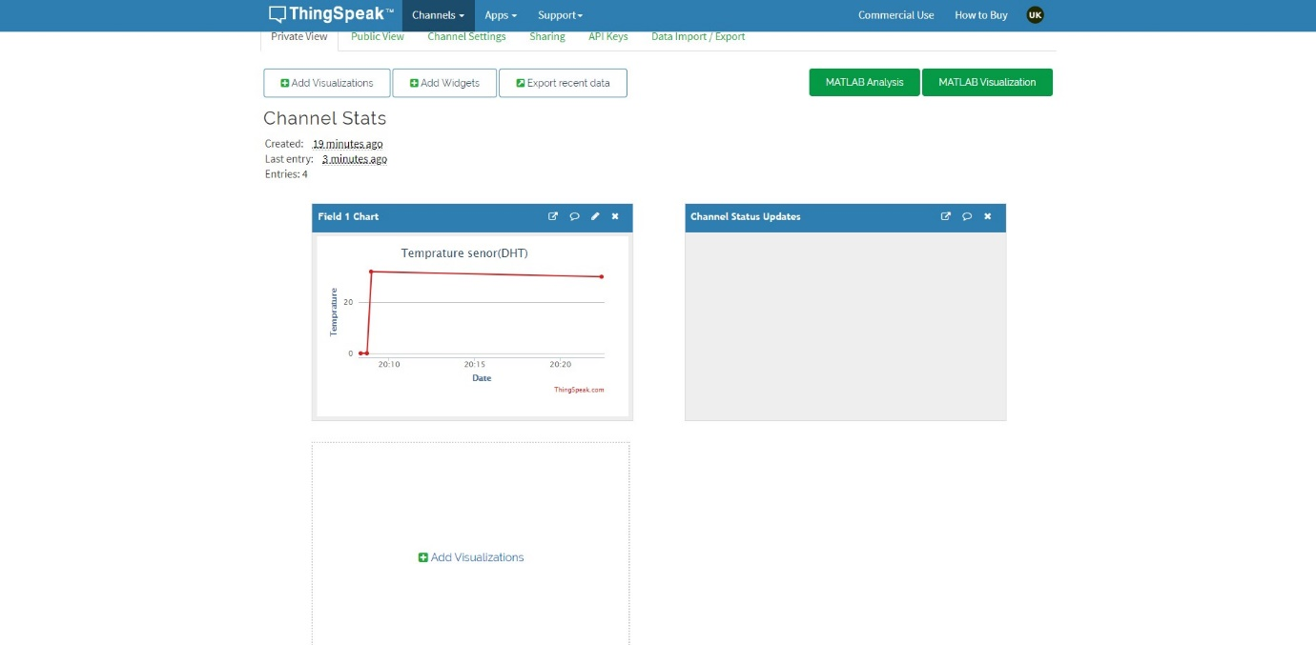

After reading the values, the Arduino uses these values to **control devices in the home.**

If the detected Temprature from the DHT senor is greater than **40C.** it will **initiate an event through IFTTT applet**, which then sends an email to the user.

**Note: -** **React option** is used to initialize the request to the IFTTT applet.

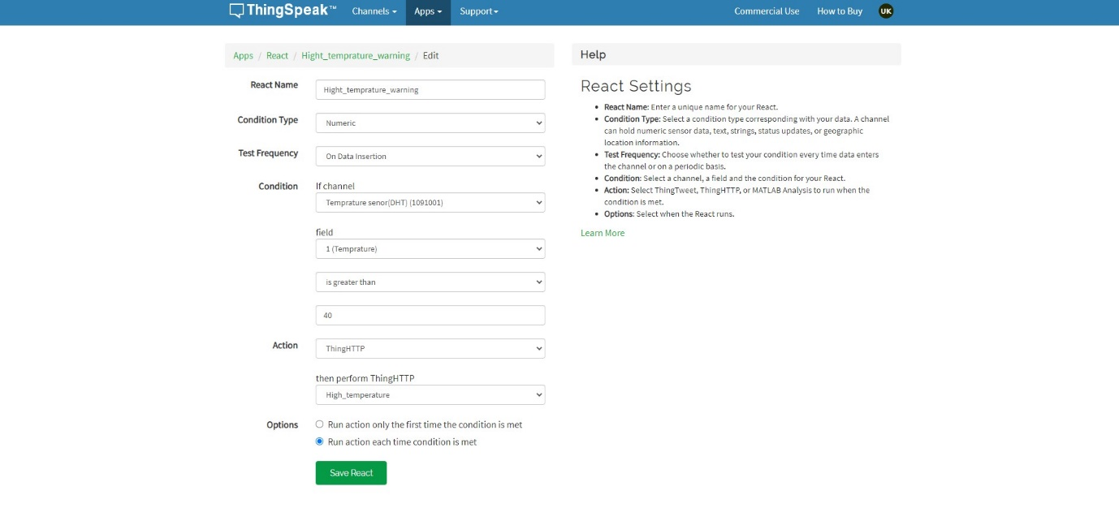

It also triggers a **think HTTP** action to make the request for the applet.

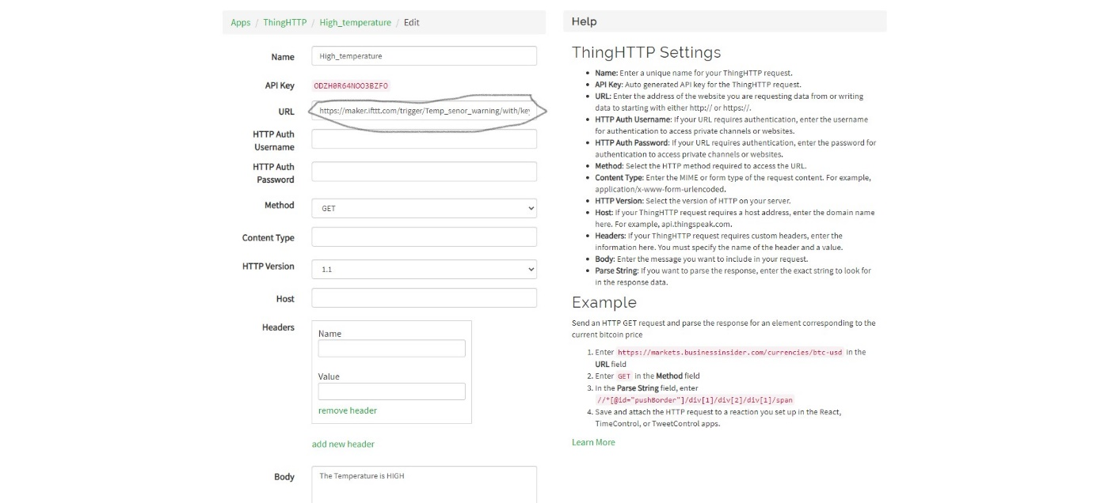

**Note: - The** URL highlighted is for making request to the IFTTT email applet. **(Webhooks)**

**Working Flowchart: -**

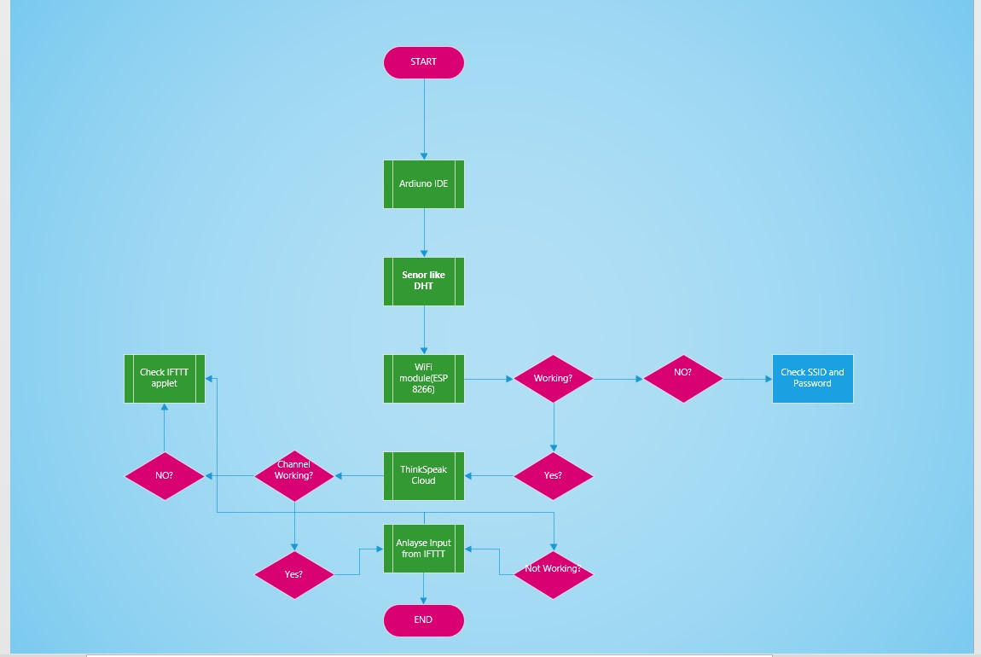

**Code Description: -**

**Note: - Full codes can be found in codes Folder.**

1. **IFTTT/Wi-Fi controller: -** The code tries to establish a Wi-Fi connection with the AT commands in the Arduino. After establishing a successful connection, it connects to the ThinkSpeak Cloud in order to send test Data.

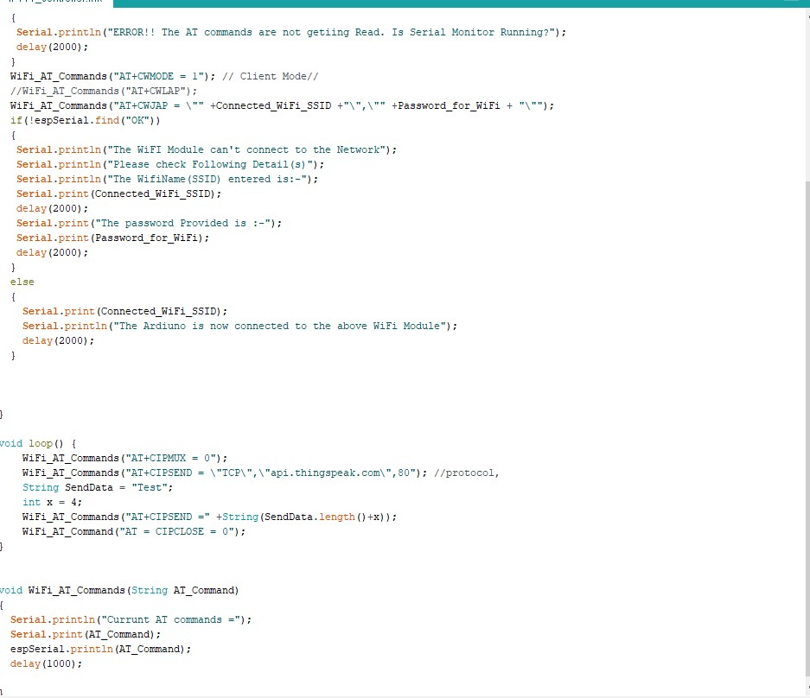

1. **DHT Controller: -**  The code tries to establish a connection with DHT controller, in order to send values/readings to ThinkSpeak cloud Channel using Wi-Fi module (ESP 8266)

**Note: - Channel API keys can be found in ThinkSpeak channel Folder.**

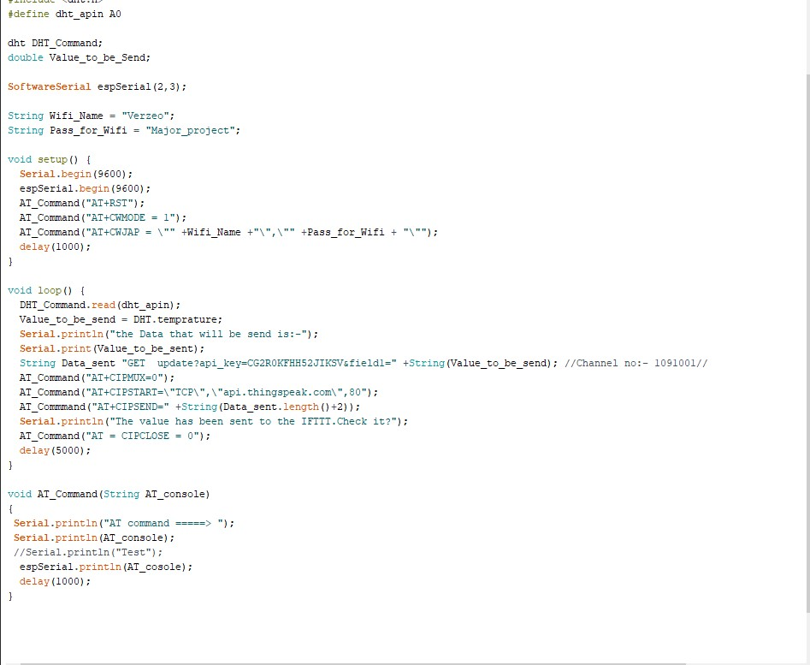

1. **ThinkSpeak read code: -** This code tries to extract data from the ThinkSpeak channel, which is then used to control of the status of the BULB.

**Note: - Use WiFi_IFTTT controller in order to connect to WIFI. This code is in present in the WiFi_IFTTT folder.**

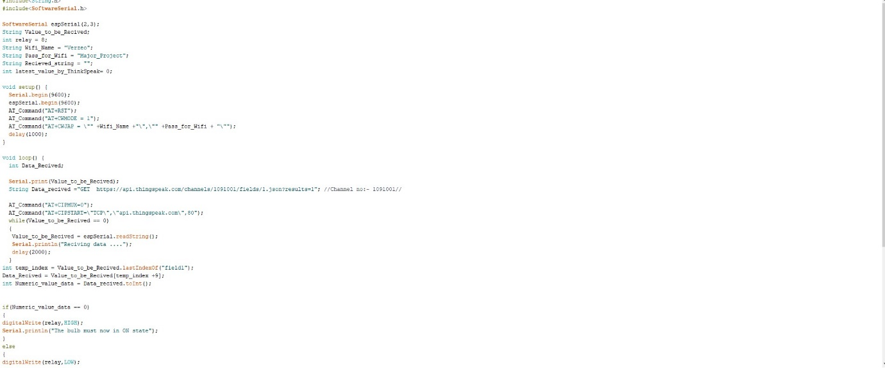

.

.

.

.

.

Google classroom code :-**IOT05B6**

**Link :-** <https://classroom.google.com/u/1/c/MTE0NDcwNjM5NDc0>